Tie One On!!

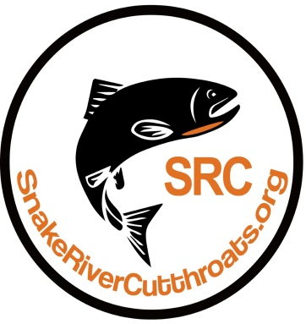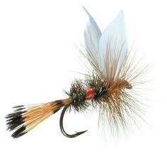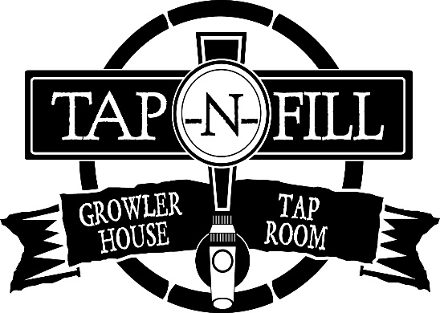

Enjoy a beer and a fly tying demonstration by local expert
Brandon Morrison

Tuesday, March 20 from 7:00 PM to 8:00 PM
At the TAP-n-FILL
1494 Milligan Road, Idaho Falls

Door Prizes !! Great Beer !! Door Prizes !!

Check out the website: www.snakerivercutthroats.org

